1. **Demonstrate on How to create and setup Metamask account and wallet?**

First step: search on chrome Metamask extension for chrome.

Second step: Install it

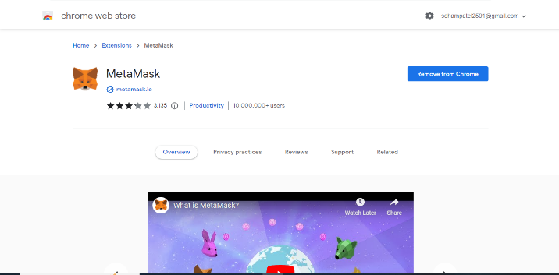

Third step: Pin to symbol

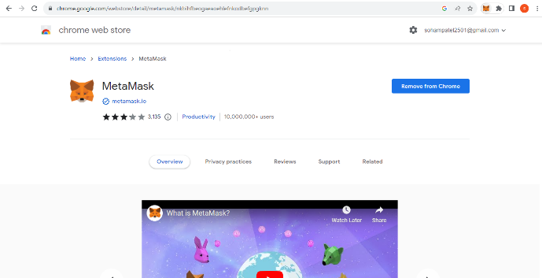

Fourth step: create a password

Fifth step:

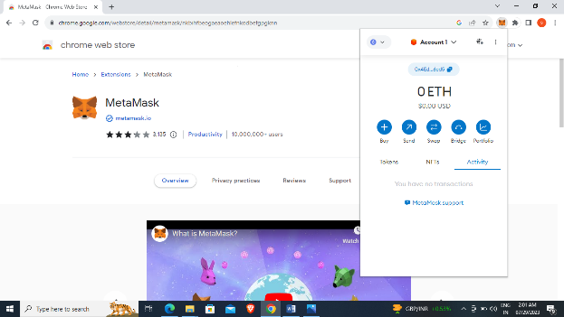

1. **How to create your own Cryotocurrency token on ethreum Blockchain an Mint your own Cryotocurrency token on ethreum Blockchain?**

1.Add metamask and create a wallet.

2. Buy test ether faucet and crete token mint.

3. mint.trustswap and after connect wallet

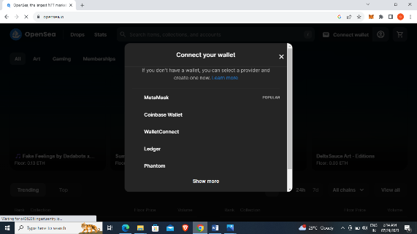

4.select network

.

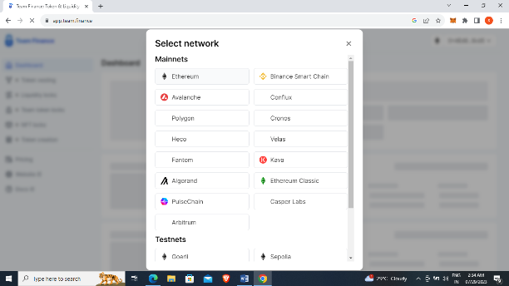

5. click to create token

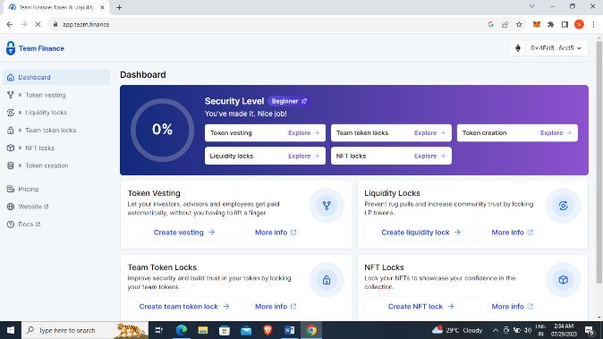

6. add features and click mint and burn function

.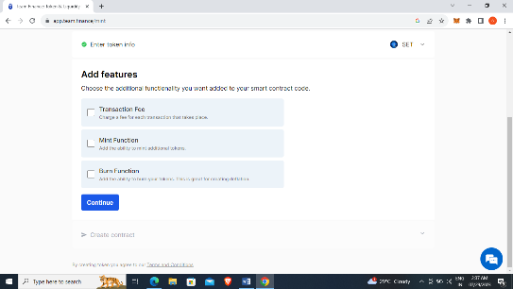

7.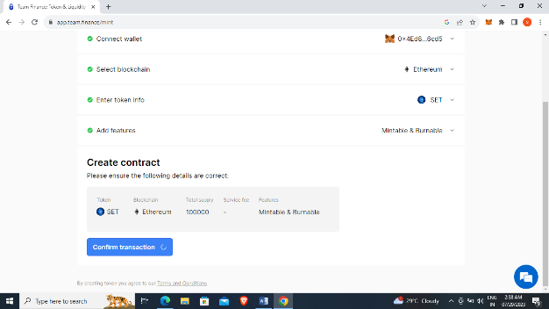

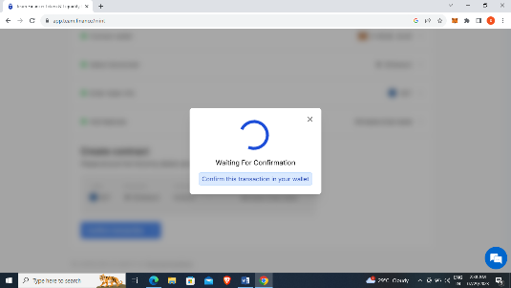

8.